[Resource Center | U.S. Department of the Treasury](https://www.google.com/search?newwindow=1&sca_esv=595369570&sxsrf=AM9HkKmGnhxVv_xEx-8nU0pjtWnNmD7vbQ:1704304657739&q=US+TReasury+Bill+24&spell=1&sa=X&ved=2ahUKEwjL7NnN5cGDAxXPv4kEHRsfA8AQBSgAegQICBAC&biw=1266&bih=700&dpr=1.58)

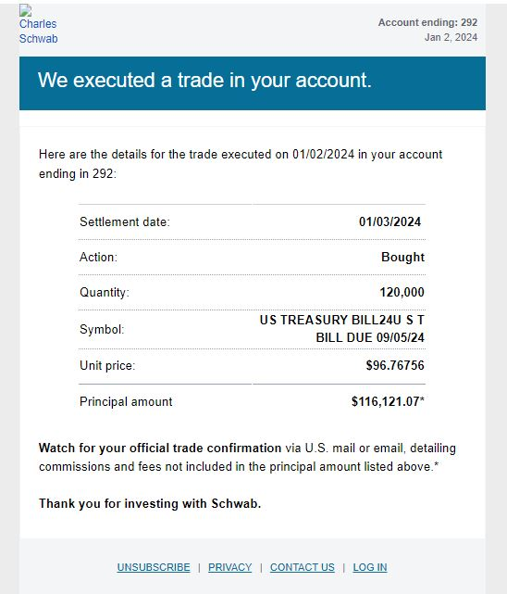

Using your calcuator divide 116121.07 by 96.76756

|  |  |  |
| --- | --- | --- |
| Settlement date |  | 01/02/2024 |
| Action |  | Bought |
| Quantity |  | 120,000 |
| Symbol |  | US Treasury Bill 24 UST Bill Due 09/05/24 |
| Unit price |  | $96.76756 |
| Principal amount |  | $116,121.07 |
| [($96.76756)*120000](https://sagecell.sagemath.org/) | = | **1.1612107**2000000e7 |
|  |  |  |
|  |  |  |
|  |  |  |
|  |  |  |

Using your calcuator divide 116121.07 by 96.76756